

Technical Document

An Example of Reusing HealthWebMapper:

Southern California Cancer Geospatial Modelling Viewer

Project conducted by:

San Diego State University

5500 Campanile Drive

San Diego, CA 92182-4493

Report prepared by:

Haihong Huang

**Department of Geography, San Diego State University**

June 28, 2018

# Abstract

This report introduces how to reuse the source code of “HealthWebMapper” a web-based health data mapping tool developed by Dr. Su to visualize cancer GWR modelling results. The procedure mentioned in this report is similar to the tutorial in Dr. Su’s technical report (Web-based Health Data Mapping Tools for San Diego County) about how to reuse the source code for new dataset (p.12-18) but contains differences in details. Thus, this report serves as a unique reuse case for visualizing cancer GWR modelling results.

**Part 1 Raw data Description**

1. Sounthern_CA_WGS84 shapefiles(including dbf,prj,sbn,sbx,shp,shp.xml,shx)(Fig.1)

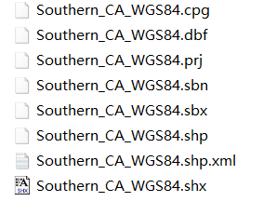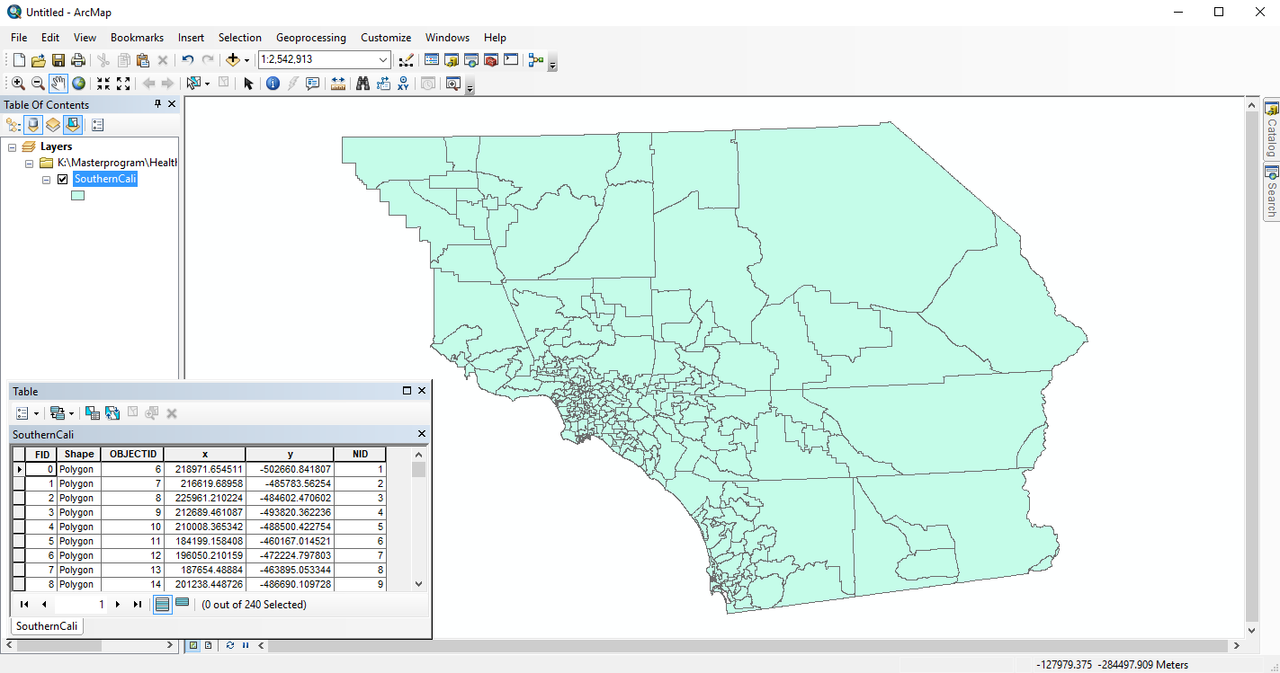

Fig. 1 SounthernCalifornia shapefiles and open it in ArcMap

If your original shpfiles projection is not WGS 1984, you need to transform your data following ArcMap🡪ArcToolBox🡪Data🡪Management Tools🡪Projections and Transformations🡪Project (see Fig. 4)

1. Raw data for the left map: Brst_ISMR_GWR_cancer_results.csv and Crcm_ISMR_GWR_results.csv (Fig.2)

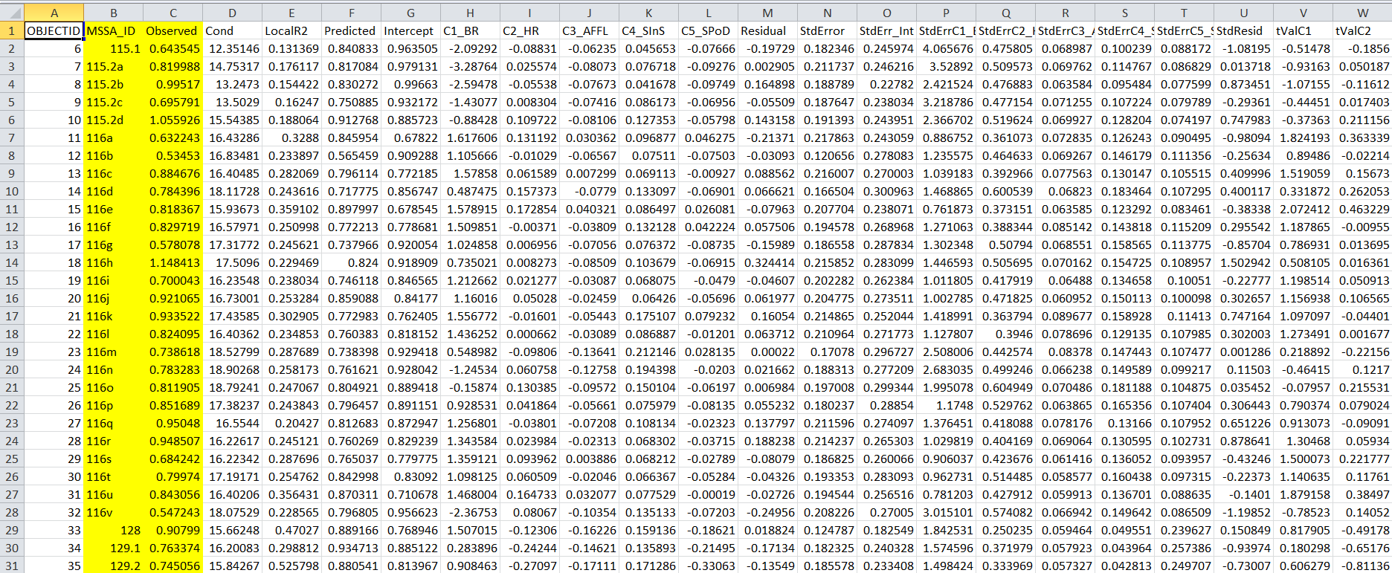

Fig.2 GWR_cancer_ism.csv showed in EXCEL, containing MSSA_ID, cotaining Breast Cancer data and highlight desired columns

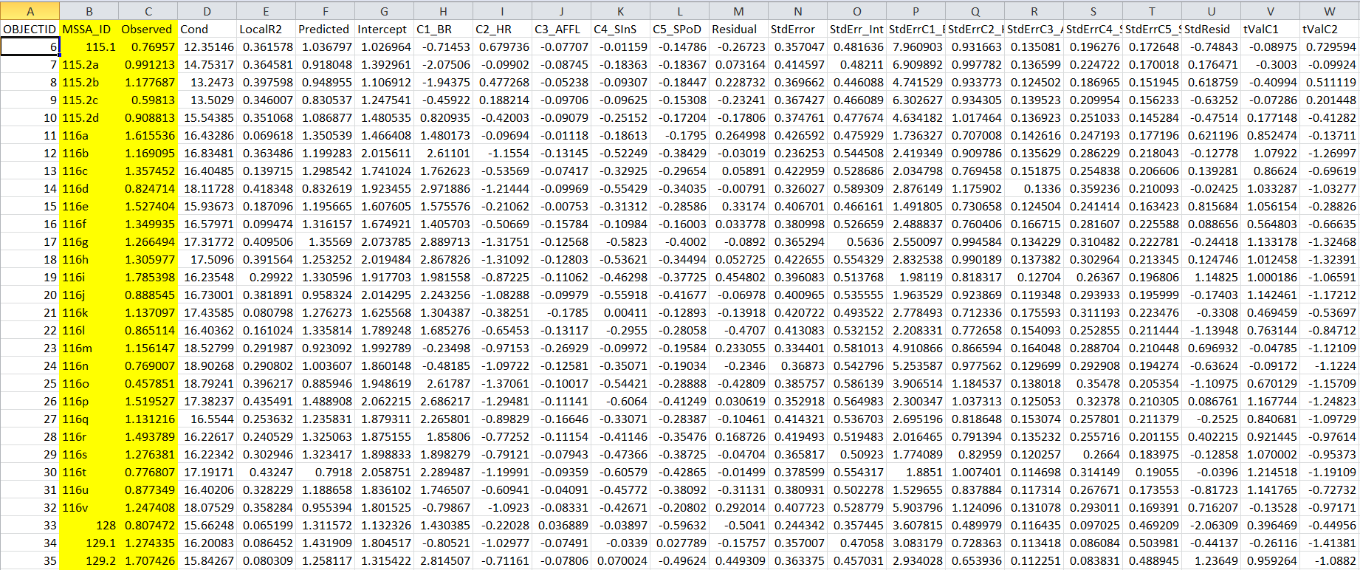

Fig.3 Crcm_ISMR_GWR_results.csv showed in EXCEL, containing Colorectal Male data and highlight desired columns

Since I only need to column MSSA_ID and Observed in both csv files,remove other collomns and add column “CANCER_TYPE”. Then, organize desired data into one file called “GWR_cancer_ism.csv” with 3 columns and the following 3 headers :

1. “MSSA_ID”: unique ID for each polygon
2. “CANCER_TYPE”: in this cace value is either “Breast Cancer” or “Colorectal Male”
3. “Indirect standardized mortality”: columns named “Observed” in both files
4. Raw data for the right map: socioeconomic.csv

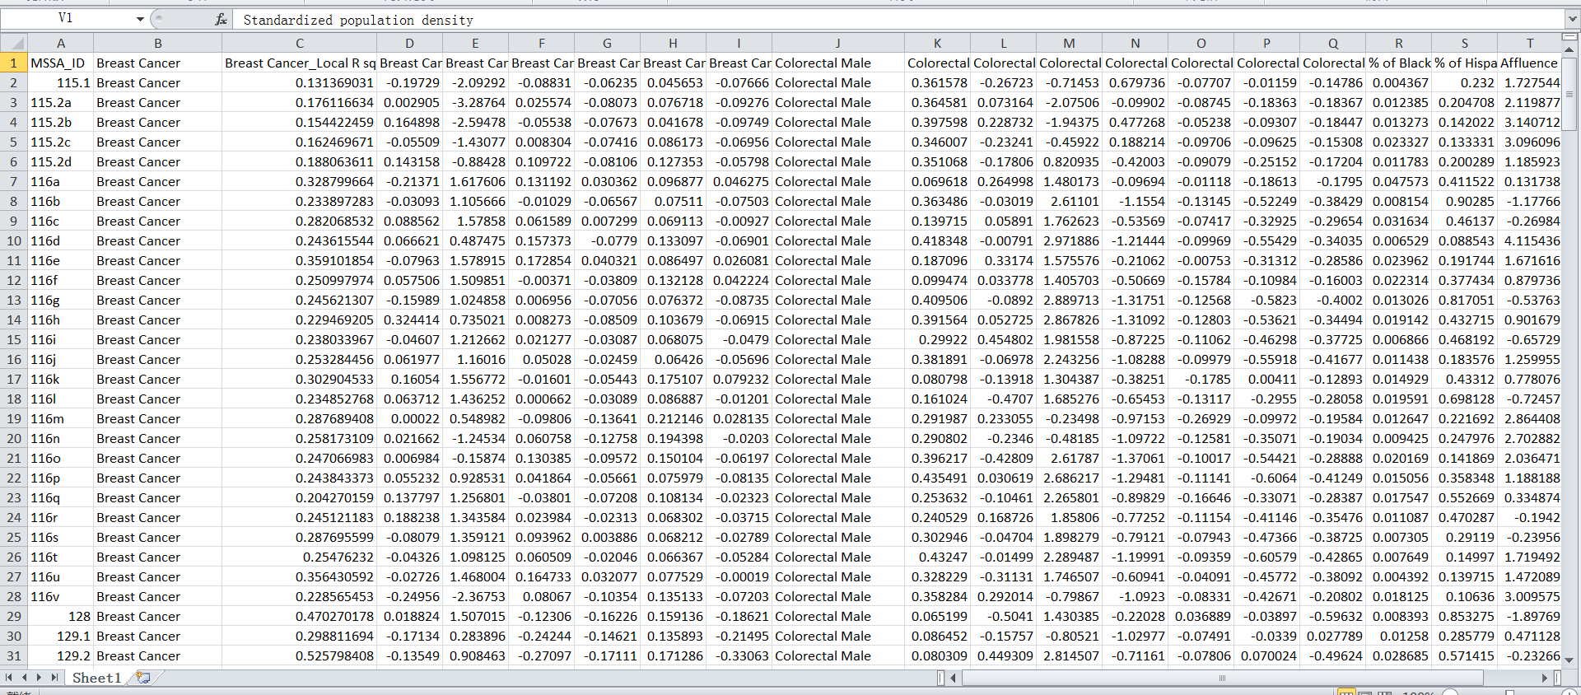

Fig.4 socioeconomic.csv showed in EXCEL

It contains 22 columns, headers are:

"MSSA_ID",

"Breast Cancer",

"Breast Cancer_Local R square",

"Breast Cancer_Residual",

"Breast Cancer_% of Black population",

"Breast Cancer_% of Hispanic population",

"Breast Cancer_Affluence score",

"Breast Cancer_Standardized % of health-insured population",

"Breast Cancer_Standardized population density",

"Colorectal Male",

"Colorectal Male_Local R square",

"Colorectal Male_Residual",

"Colorectal Male_% of Black population",

"Colorectal Male_% of Hispanic population",

"Colorectal Male_Affluence score",

"Colorectal Male_Standardized % of health-insured population",

"Colorectal Male_Standardized population density",

"% of Black population",

"% of Hispanic population",

"Affluence score",

"Standardized % of health-insured population",

"Standardized population density"

Tips: Before you start customzing HealthWebMapper source code for your own dataset, you may have a huge csv file containing all the data. However, you need to first decide which data you want to show in the left or right map, what does the drop-down menu look like. Then, according to your design and original menu sturcture, separate the data into two different csv files for each map and orgnized it. Every csv files should have a header for each column.

**Part 2 Conversion of raw data to js. files**

In Dr. Su’s technical report, the method she adoped to reuse the tool is to “force overwrite of existing identically named objects”. Thus, you need to first convert raw data to the formats that match the original data. Coversion procedure showed in Table 1.

|  |  |  |
| --- | --- | --- |
| Raw data to js files | Original data in HealthWebMapper to be replaced | method |
| Southern_CA_WGS84.shp  to  Southern_CA_WGS84.js | Polygon.js or MSSA_SD_Imperial.js | shp to js   1. ArcMap🡪ArcToolBox🡪Data Management Tools🡪Projections and Transformations🡪Project(see Fig. 4) 2. Convert .shp with WGS 1984 projection to geojson through Mapshaper(http://mapshaper.org/) 3. Edit geojs file by adding “var stateData=”and save as .jsfile |
| GWR_cancer_ism.csv  to  GWR_cancer_ism.js | Cancer.js or  late_stage_dx_SD_Imperial_fake.js | csv to js   1. Convert .cvs to geojson via   <http://www.convertcsv.com/csv-to-geojson.htm>   1. Edit geojson file by adding “var CANCER_SD_Imperical=”and save as .js file |
| socioeconomic.csv  to  socioeconomic.js | CENSUS2010_v2.js or  MSSA_ACS_SD_Imperial_simple.js | csv to js   1. Convert .cvs to geojson via   <http://www.convertcsv.com/csv-to-geojson.htm>   1. Edit geojson file by adding “var census=”and save as .js file |

Table 1 converstion of raw data to desired js. format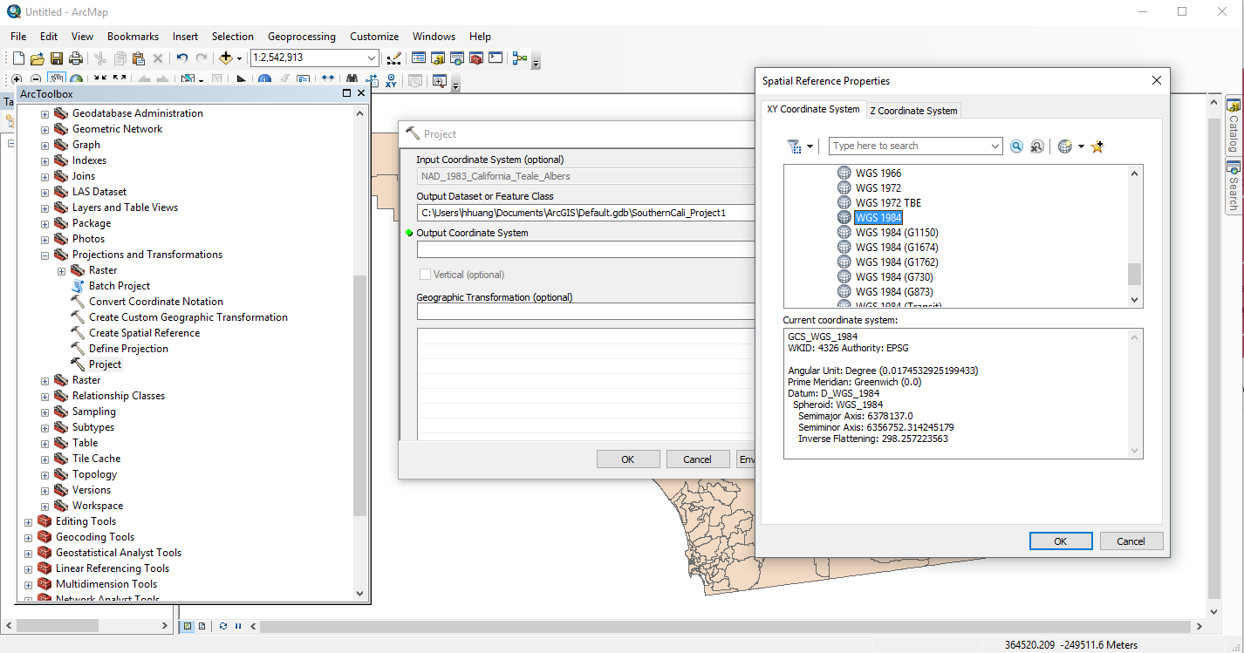

Fig.5 project shapefiles to WGS84 in ArcMap (if you original data projection is not WGS 1984)

After conversion, the three .js files should look like below:

1. Southern_CA_WGS84.js

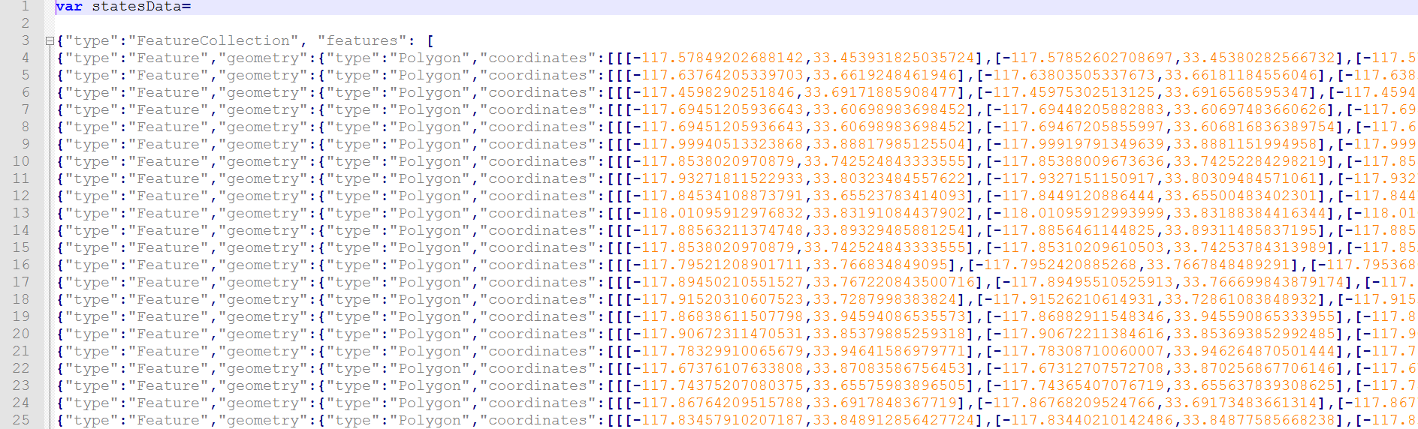

Fig.6 Southern_CA_WGS84.js

1. GWR_cancer_ism.js

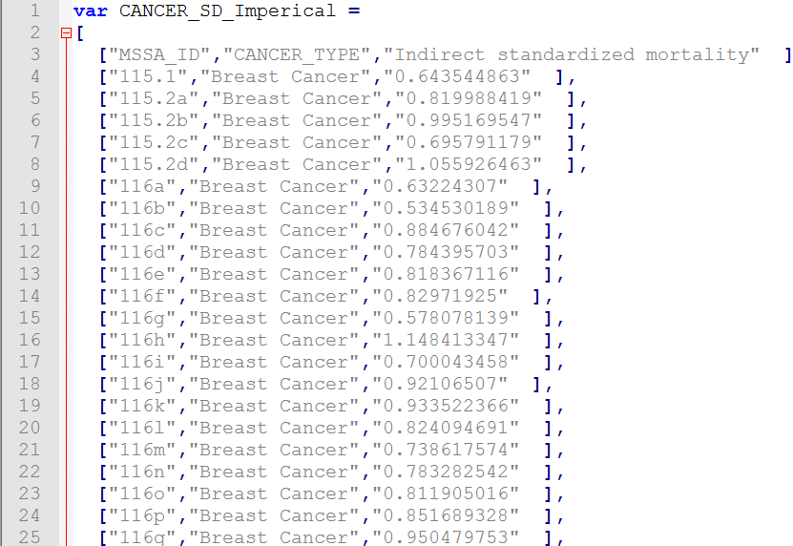

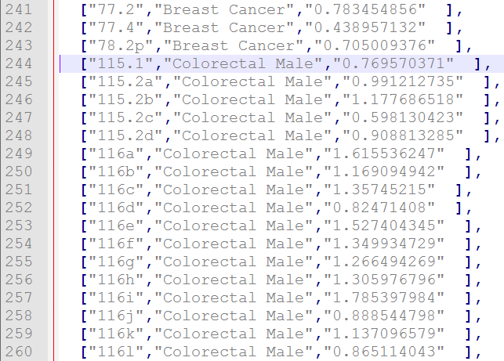

Fig.7 GWR_cancer_ism.js

1. Socioeconomic.j

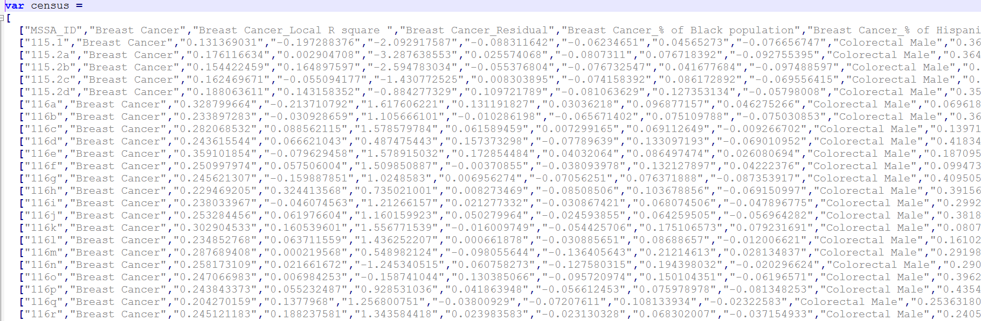

Fig.8 Socioeconomic.js

Tips: There is no much difference between csv and js, only js files has [] in each line and all the data is assigned to a variable named after you (e.g. var census = []). Be carful to keep the original variable names because these names are still used in the source code.

Once you get these 3 js files, put them into your source code folder, in this case js folder which is in the same level of index.html. You can place it wherever you want, but remember to provide the correct directory in you source code.

**Part 3 Customize source code of HealthWebMapper**

Then, you can follow Dr.Su’s technical report, she provide step by step procedure about how to reuse the tool illustrated in the example of “San Diego_Imperial_final”. The procedure can be summarized as:

1. Change webpage title



The change is seen as below:



1. Change header title



The change is seen as below:



1. Replace js files

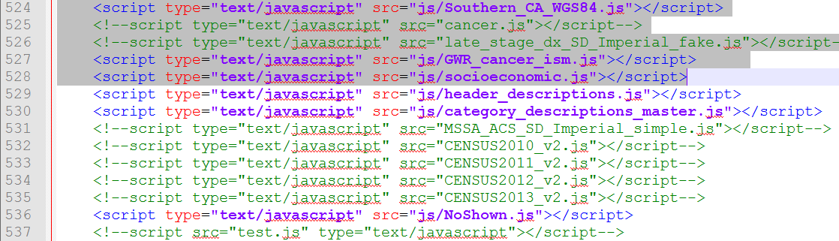

*Southern_CA_WGS84.js* replaces *polygon.js*,

*GWR_cancer_ism.js* replaces *cancer.js*,

*socioeconomic.js* replaces *CENSUS2011_v2.js , CENSUS2011_v2.js and CENSUS2011_v2.js*

Keep other .js files.

1. Change left menu

In the left menu, I want to visualize “Indirect standardized mortality” for both cancer types. The menu should look like below:

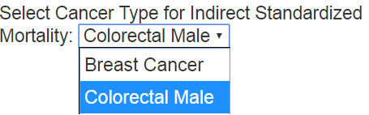

1. In the source code, first comment unnecessary “menu_L2” and “menu_L4”

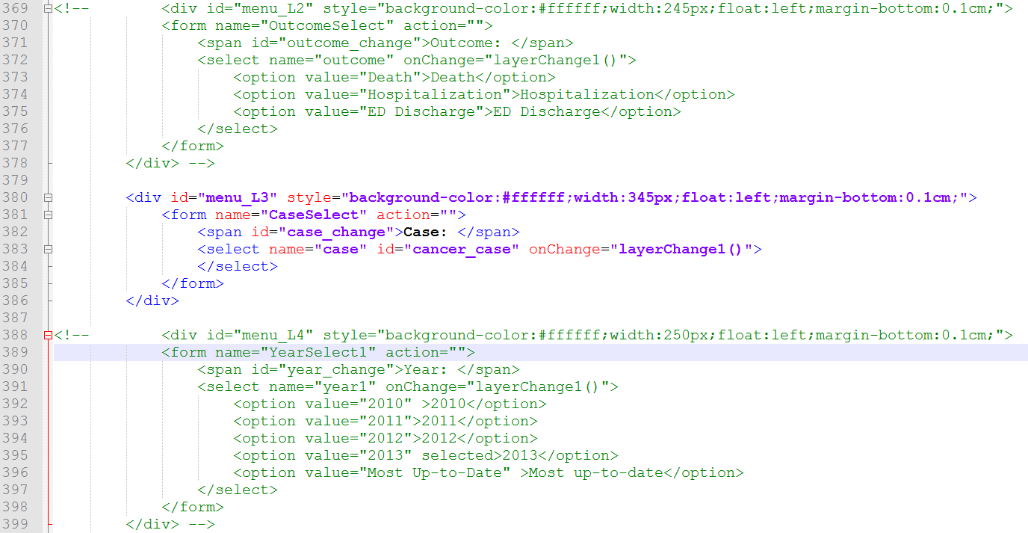

1. Second, put “display:none;” after menu_L3 and menu 7

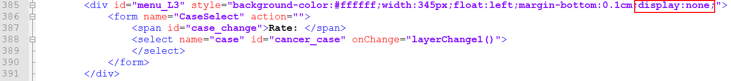

1. Last, change menu_L1 name to “Select Cancer Type for Indirect Sandardized Mortality”

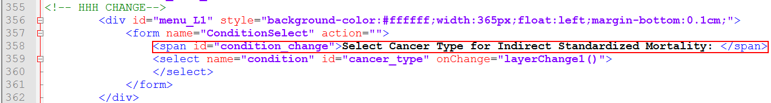

1. Change right menu

In the right map menu, I group the 21 columns into 3 categories. Then based on your selection in first drop-down menu, the contents in second drop-down menu will change. The selection structure showed as below:

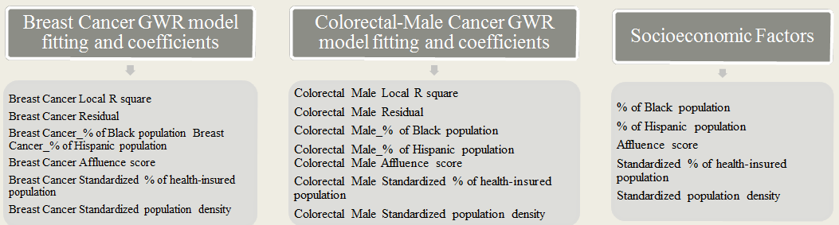

1. First, comment “menu_R2”, then put “display:none;” behind “menu_R3”

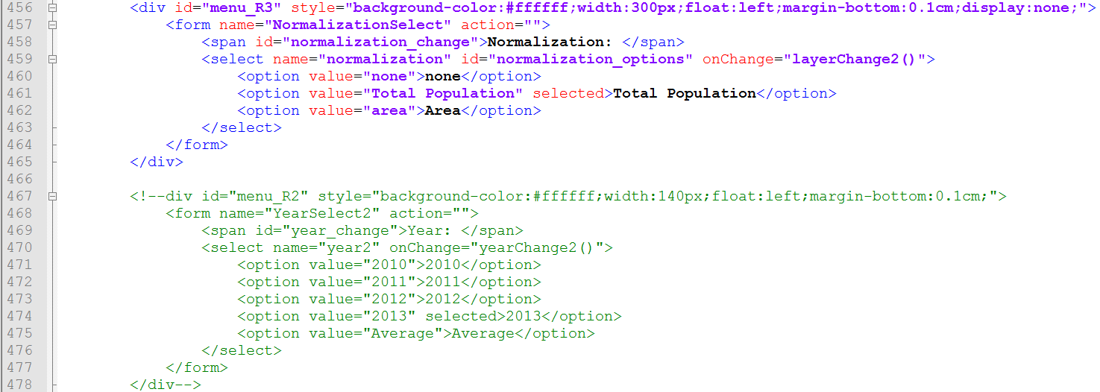

1. Then, change names of menu_R0 and menu_R1 to “Select” and “Select Factors” separately.

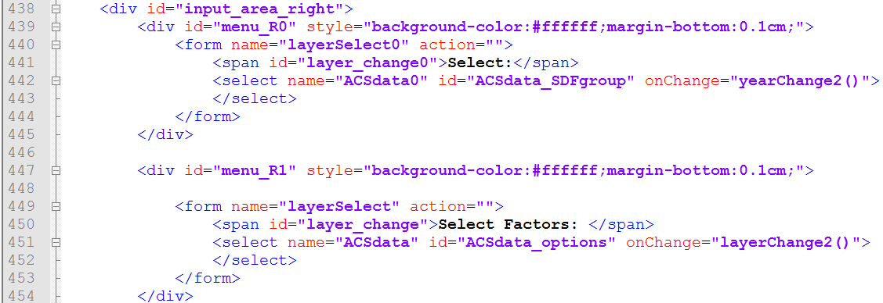

The customized menus looks like below:

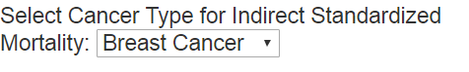

Left map menu

Right map menu

1. Force overwrite of existing named objects
2. For Southern_CA_WGS84 data:

First, add the following lines(544-549) after <script…> to the code.

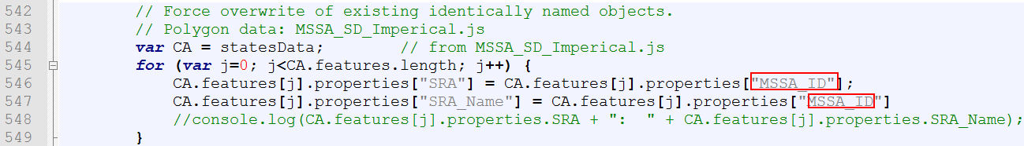

1. For Cancer data: add the following lines to the code

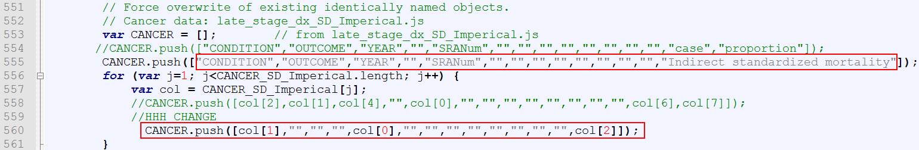

1. In “Header_descriptions”: add the following code to replace the old header descriptions

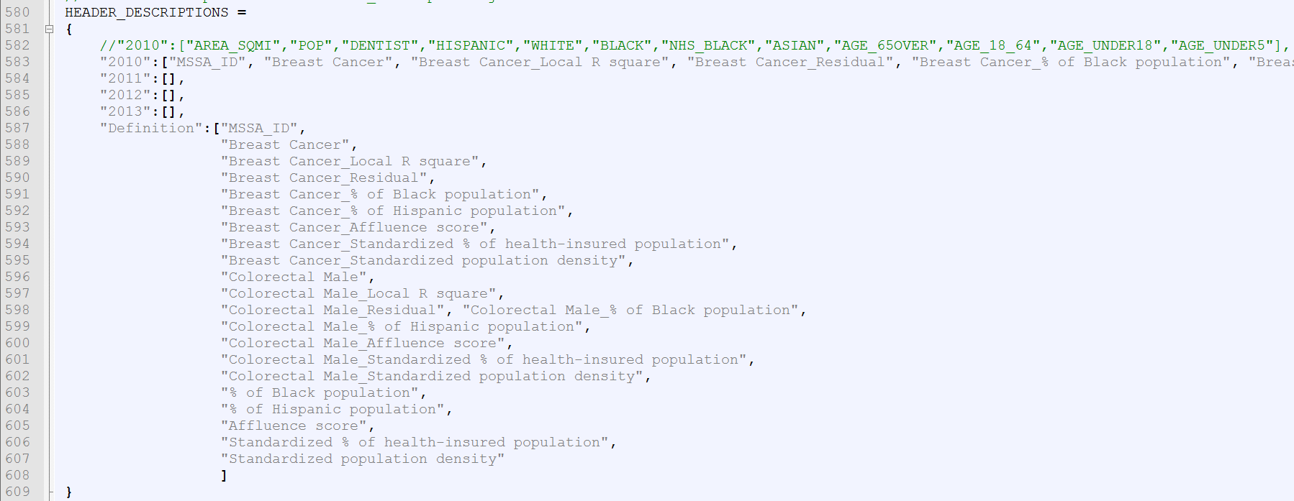

1. For socioeconomic.js for the right map :

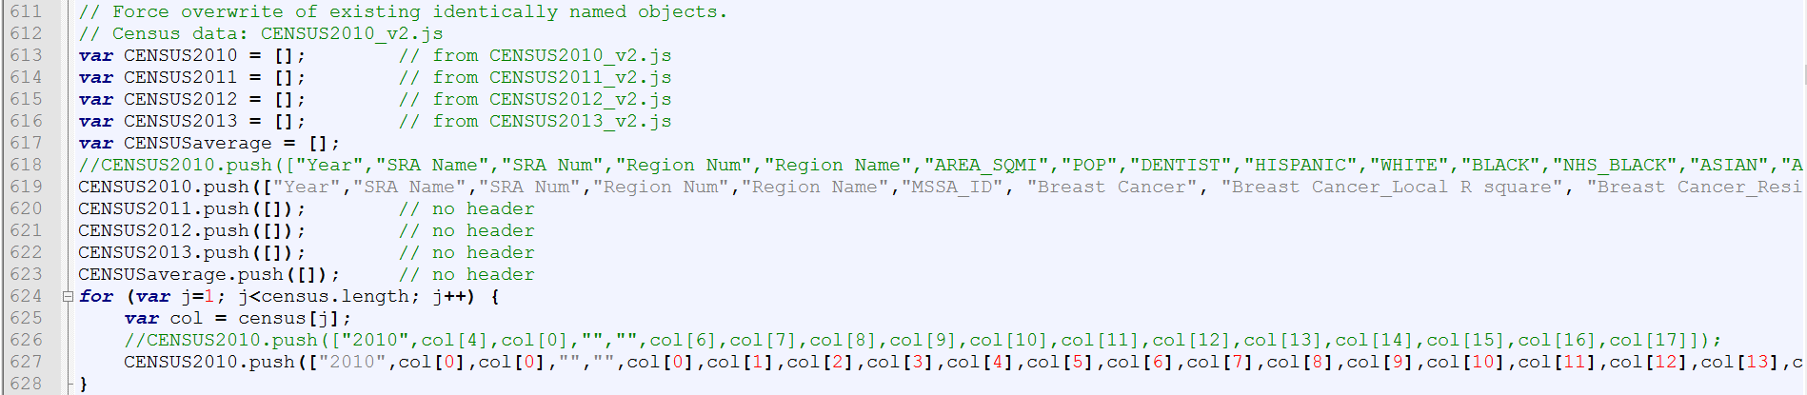

1. This program does not need to use the function “no show”. So two variables below need to be initialized.

屏幕剪辑

1. Comment all “selectedOutcom” and “YearSelect1” showed in the following lines. Your can use Ctrl+F to search for “selectedOutcom” and and “YearSelect1” quickly. This step is the result of debugging which is not listed in Dr.Su’s technical report,

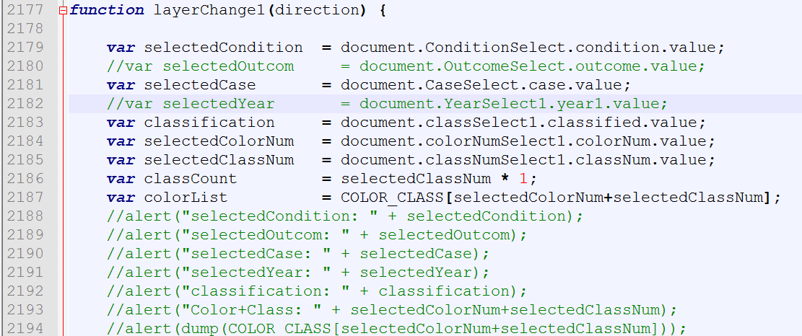

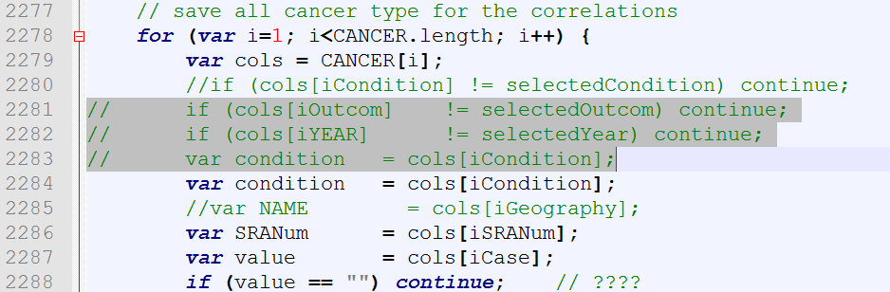

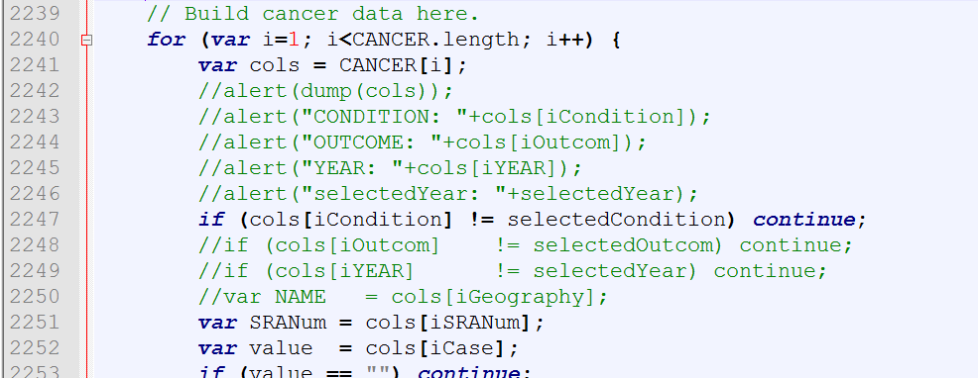

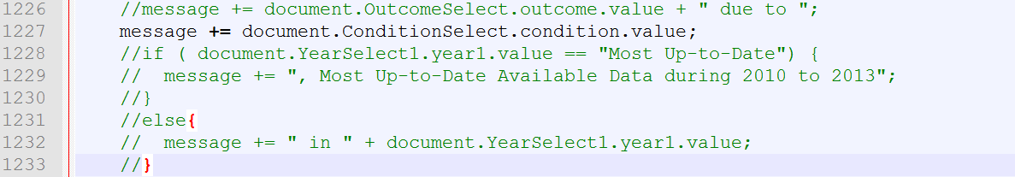

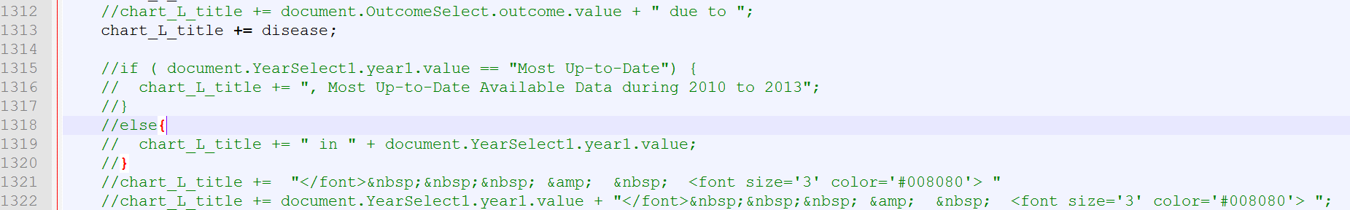

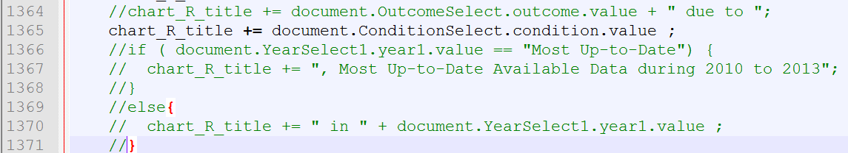

1. Change map center and minZoom and maxZoom according to your need

